**Assignment-1**

**1. List the advantages of using systems analysis and design techniques in approaching computerized**

**information systems for business.**

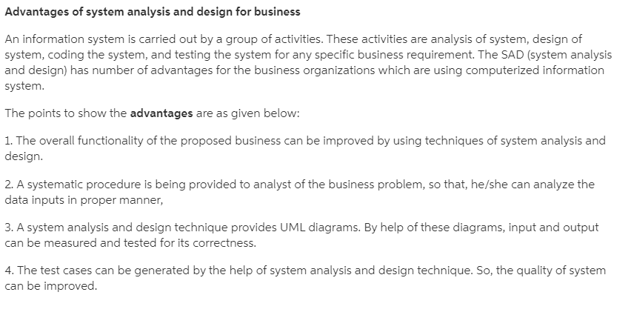

**2. List three roles that a systems analyst is called upon to play. Provide a definition for each one.**

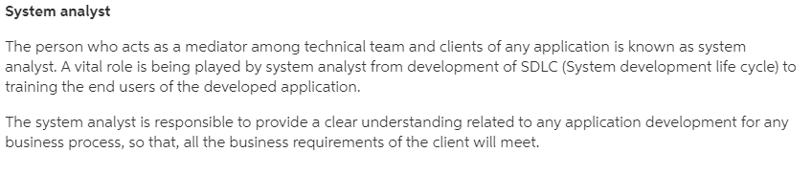

1. Consultant: an outside expert who brings fresh perspective and relies on systematic approaches and project management fundamentals, versus intimate knowledge of organization's culture, to assess business challenges and recommend appropriate information system solutions.
2. Supporting Expert: an inside expert who serves as a hardware and software resource with intimate knowledge of an organization's culture to project managers and focuses on modifications that affect smaller groups.
3. Agent of Change: anytime an analyst stays in an organizational longer than two weeks and works with others to facilitate change by performing activities within the system development lifecycle.

**3. What personal qualities are helpful to a systems analyst? List them.**

1. Problem solver
2. Communicator
3. Strong personal
4. professional ethics
5. Self-motivated
6. Self-disciplined

**4. List and briefly define the seven phases of the systems development life cycle (SDLC).**

* 1. Identify problems, opportunities, and objectives - Interviews user management, summarize information, estimates scope, documents results.
  2. Determining human information requirements - determines needs of users involved.
  3. Analyzing system needs – Use tools and techniques that help make determinations.

4.Designing the recommended system – Use previously collected info to design info system.

5.Developing and documenting software – works with programmers to develop software.

6. Testing and maintaining the system – test system to catch problems.

7. Implementing and evaluating the system – train users, convert old system to new.

**5. What is UML?**

Unified Modeling Language – a standardized modeling language in which objects that are created include not only code about data but also instructions about the operations to be performed on the data.

* UML is different from the other common programming languages such as C++, Java, COBOL, etc.
* UML is a pictorial language used to make software blueprints.

This 2 is optional (not necessary to write it)

* UML can be described as a general purpose visual modeling language to visualize, specify, construct, and document software system.
* Although UML is generally used to model software systems, it is not limited within this boundary. It is also used to model non-software systems as well. For example, the process flow in a manufacturing unit, etc.

**Assignment-2**

**1.What kinds of information should be sought in interviews?**



Interviews reveal information about interviewee opinions, interviewee feelings about the current state of the system, organizational and personal goals, and informal procedures.

**2. List the five steps in interview preparation.**

The five steps in interview preparation are:

(a) reading background material

(b) establishing interview objectives

(c) deciding who to interview

(d) preparing the interviewee

(e) deciding on question types and structure

**3. Define what is meant by open-ended interview questions. List eight benefits**

**and five drawbacks of using them.**

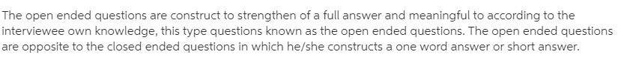

The benefits of using open-ended questions are numerous and include the following:

1. Putting the interviewee at ease.
2. Allowing the interviewer to pick up on the interviewee’s vocabulary, which reflects his or her education, values, attitudes, and beliefs.
3. Providing richness of detail.
4. Revealing avenues of further questioning that may have gone untapped.
5. Making it more interesting for the interviewee.
6. Allowing more spontaneity.
7. Making phrasing easier for the interviewer.
8. Using them in a pinch if the interviewer is caught unprepared.

As you can see, there are several advantages to using open-ended questions. There are, however, also many drawbacks:

1. Asking questions that may result in too much irrelevant detail.
2. Possibly losing control of the interview.
3. Allowing responses that may take too much time for the amount of useful information gained.
4. Potentially seeming that the interviewer is unprepared.
5. Possibly giving the impression that the interviewer is on a “fishing expedition” with no real objective for the interview.

**4.When are open-ended questions appropriate for use in interviewing?**

**(Skip some lines. No need to write all of it. But write the bullet points).**

Open-ended interview questions are appropriate when the analyst is interested in breadth and depth of reply.

Open-ended questions are queries that prompt the candidate to provide a detailed explanation. Many employers ask open-ended questions to get a better insight into the candidate’s thought process and personality. These questions can also reveal whether candidates have enough experience and qualifications for a specific job by explaining how they apply their knowledge and skills.

Since there are no right answers to open-ended questions, some candidates might find them challenging. However, the fact that there is no correct answer can be an advantage, offering flexibility in the way they approach the question. An ideal answer will show that the candidate is ideal for the open position and showcase their previous experience in similar roles.

They can be used at any time when it’s more important to the interviewer to elicit thoughts and opinions and insights than to get definitive answers.

Situations may include:

* Informational interviews with business prospects
* Discovery sessions with potential or new clients
* Feedback sessions with existing clients
* Interviews for profiles
* Customer satisfaction surveys

**5. Define what is meant by closed interview questions. List six benefits and four**

**drawbacks of using them**.

The alternative to open-ended questions is found in the other basic question type: closed questions. Such questions are of the basic form “Is it easy to use the current system?” and, “How many subordinates do you have?” The possible responses are closed to the interviewee, because he or she can only reply with a finite number such as “None,” “One,” or “Fifteen.” Some examples of closed questions are listed below.

The benefits of using closed questions of either type include the following:

1. Saving time.
2. Easily comparing interviews.
3. Getting to the point.
4. Keeping control over the interview.
5. Covering lots of ground quickly.
6. Getting to relevant data.

The drawbacks of using closed questions are substantial, however. They include the following:

1. Being boring for the interviewee.
2. Failing to obtain rich detail (because the interviewer supplies the frame of reference for the interviewee).
3. Missing main ideas for the preceding reason.
4. Failing to build rapport between interviewer and interviewee.

**6.When are closed questions appropriate for use in interviewing?**

Closed interview questions limit the number of possible responses. Closed interview questions are appropriate for generating precise, reliable data that is easy to analyze. The methodology is efficient, and it requires little skill for interviewers to administer.

(write 3/4 bullet point. Don’t write all of it.)

* When you want to get fast facts or basic biographical details
* When you need answers to be exact
* When you are collecting quantitative data
* When the answer provided will determine whether or not it makes sense to continue pursuing a lead (especially related to budget and timeline)
* When you are setting goals and KPIs that you’ll be expected to deliver against
* When your fact-checking
* When your legal department is going to want to put information into a contract

1. **What is a probing question? What is the purpose of using a probing question in interviews?**

The purpose of the probe is to go beyond the initial answer to get more meaning, to clarify, and to draw out and expand on the interviewee’s point. Probes may be either open-ended or closed questions.

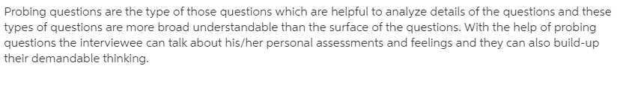

The purpose of probing questions is:  
• To get more meaning  
• To clarify  
• To draw out and expand on the interviewee’s point

1. **Define what is meant by pyramid structure. When is it useful to employ this structure in interviews?**

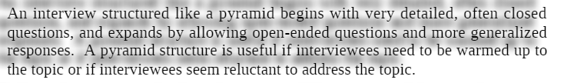

Using this form, the interviewer begins with very detailed, often closed, questions. The interviewer then expands the topics by allowing open-ended questions and more generalized responses, as shown in Figure 1 below.

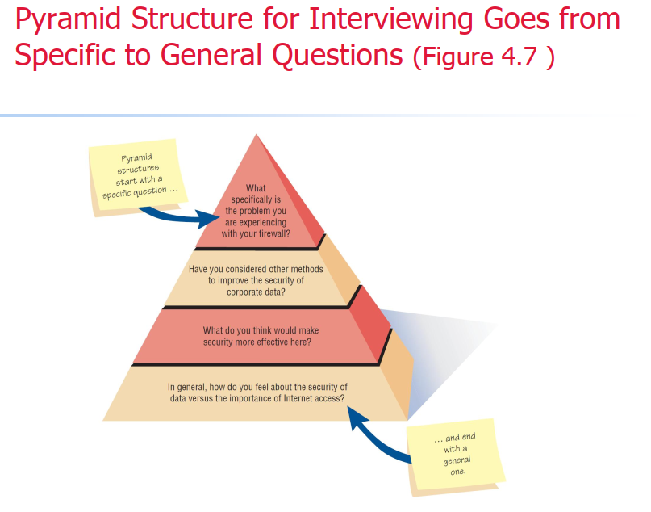

**9. Define what is meant by funnel structure. When is it useful to employ this structure in interviews?**

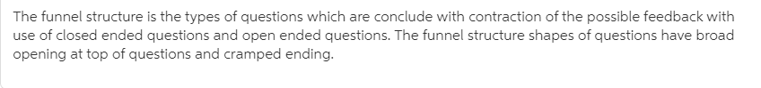

Begins with generalized, open-ended questions. Concludes by narrowing the possible responses using closed questions. Provides an easy, nonthreatening way  
to begin an interview. Is useful when the interviewee feels  
emotionally about the topic.

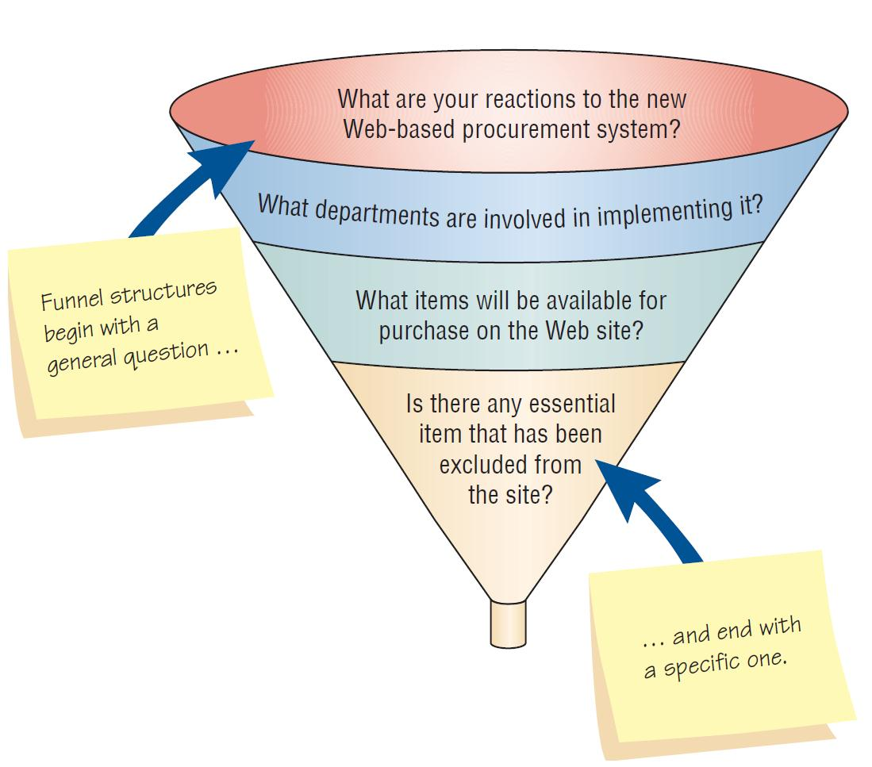

**10.Define what is meant by diamond-shaped structure. When is it useful to employ this structure in interviews?**

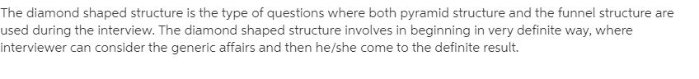

A diamond-shaped structure begins in a very specific way. Then more general issues are examined. Concludes with specific questions. Combines the strength of both the pyramid and funnel structures. Takes longer than the other structures.

